
Le Corum- Palais des Congrès - Opéra Berlioz

Exhibition

File



Summary

○ Names of Organizers p 3 – 4

○ Sch edules and access for stands setting up and dismantling p 5

○ How to collect packages to Le Corum ? p 6

○ How to access to Le Corum ? p 7

○ Maps of access to Le Corum p 8 - 9

○ Exhibition services : Catering & Bar, Shipping Company p 10

○ General Instructions p 11

○ Safety – Surveillance and Caretaking p 12

○ Safety measures p 13 - 14

○ Stand Equipment p 15

○ Power supply p 16

○ Telephone – Internet p 16

○ Various services p 17

○ Rules and safety measures certificate p 18

○ Signboard form p 19

○ Technical services order form p 20

○ Stand layout p 21

Names of Organizers

 | Congress General Organization |  |  | MAREVENT
 |  |  |  | Begijnengracht 40
 |  |  |  | 9000 GENT - BELGIUM
 | Contact |  |  | Mario STAEL
 | Tel/Fax |  |  | 32 9 233 49 12
 | E.mail  Web site |  |  | mario@marevent.com  www.marevent.com
 | Congress Management Department |  |  | LE CORUM
 |  |  |  | Service Régie Congrès & Expositions
 |  |  |  | Esplanade Charles de Gaulle
 |  |  |  | BP 2200
 |  |  |  | 34027 MONTPELLIER CEDEX 1 - FRANCE
 | Tel |  |  | 33 4 67 61 67 61
 | Fax |  |  | 33 4 67 61 66 89
 | E.mail |  |  | regiecorum@montpellier-events.com
 | Invoicing Department |  |  | LE CORUM
 |  |  |  | Service Facturation Exposition
 |  |  |  | Esplanade Charles de Gaulle
 |  |  |  | BP 2200
 |  |  |  | 34027 MONTPELLIER CEDEX 1 - FRANCE
 | Tel |  |  | 33 4 67 61 67 49
 | Fax |  |  | 33 4 67 17 68 27
 | E.mail |  |  | adv@montpellier-events.com
Furniture Rental |  |  |  |  | LE CORUM
 |  |  |  |  | Service Régie Congrès & Expositions
 |  |  |  |  | Esplanade Charles de Gaulle
 |  |  |  |  | BP 2200
 |  |  |  |  | 34027 MONTPELLIER CEDEX 1 - FRANCE
Tel |  |  |  |  | 33 4 67 61 67 61
Fax |  |  |  |  | 33 4 67 61 66 89
E.mail |  |  |  |  | regiecorum@montpellier-events.com

Names of Organizers (to be continued)

Flower Decoration |  | LE CORUM
 |  | Service Régie Congrès & Expositions
 |  | Esplanade Charles de Gaulle
 |  | BP 2200
 |  | 34027 MONTPELLIER CEDEX 1 - FRANCE
Tel |  | 33 4 67 61 67 61
Fax |  | 33 4 67 61 66 89
E.mail |  | regiecorum@montpellier-events.com
CORUM Parking |  | T.A.M. SUR SITE :
 |  | Niveau –2 du parking Corum
Tel |  | 33 4 67 79 04 59
Catering on stand |  | SARL HUSSER
 |  | Brasserie du CORUM
 |  | Esplanade Charles de Gaulle
 |  | 34000 MONTPELLIER – France
Tel |  | 33 4 67 59 83 49
E.mail  Website |  | fyve34@gmail.com  www.brasserieducorum.fr
Montpellier City useful information |  | OFFICE DU TOURISME
 |  | 30, Allée Jean de Lattre de Tassigny
 |  | 34000 MONTPELLIER – France
Tel |  | 33 4 67 60 60 60
Fax |  | 33 4 67 60 60 61
E.mail |  | contact@ot-montpellier.fr
Website |  | www.ot-montpellier.fr

Schedules and access for stands
setting up and dismantling

○ Dates and Schedules setting up and dismantling of stands

- Setting up
August 25, 2018 from 8:00 am to 6:00 pm

- Exhibition
August 26, 2018 from 10:00 am to 6:00 pm
August 27, 2018 from 10:30 am to 6:00 pm
August 28, 2018 from 10:30 am to 4:00 pm

- Dismantling
August 28, 2018 from 4:00 pm to 7:00 pm

○ Place of the exhibition

Level : 0
Height : 2m40
Ground maximum load : 500 kg/sq m

○ Access - Setting up - Dismantling - Delivery

The exhibition equipment is unloaded inside Le Corum on the loading bay.

⇨ To accede to the Corum loading bay, from the centre of the town, follow the « Tunnel du Corum » direction.
⇨ At the entrance of the tunnel, take the access to Le Corum Car Park on the right and drive in front of the metal shutter marked « Corum - Quai de déchargement exposants ». See map pages 7-8.

One hour is the maximum parking time permitted.
The users of the vehicles parked at the loading bay must leave their phone number (cellular) on their windscreen.

From the loading bay two goods lifts are provided inside Le Corum, free use.

Permissible load : 4 metric tons Volume : 13 cubic meters

Height : 2.45 m

Width : 1.70 m
Length : 3.25 m

For heavy and bulky packages, the lorries must be equipped with a hatchback device to be on a level with the loading bay.

Height of loading bay : 1.20 m
Height of entrance gate : 4.00 m

○ Parking
T.A.M : Transportation of the Area of Montpellier ( see page 4)
News
Except for deliveries, the exhibitors may park in the underground car park close to Le Corum (Maximum height : 1.85 m). No booking is possible, but exhibitors may buy a special individual pass at preferential rate for more than one day car park.

How to collect packages
to Le Corum ?

○ Merchandise deliver to Le Corum

They must be delivered to the loading bay of the Corum :

Each package must be clearly marked with :

The sender’s name and address
The exact name and date of the congress
The exhibitor number of stand

Delivering address :
Le CORUM
Quai de déchargement CORUM

Le tunnel du Corum
Rue de Sully
34000 – MONTPELLIER - FRANCE

Le Corum does not provide manpower for the handling of exhibitors packages. Exhibitors have to come and pick them up themselves. At the end of the Exhibition, all packages have to be removed within
48 hours. Beyond this time, Le Corum can empty the stocking areas.

○ Opening times of loading bay

Monday to Friday from 8:00 am to 7:00 pm.
Deliveries of exhibitors packages is only allowed from :

MONDAY, JULY 16, 2018

All packages will be stocked at the loading bay, in stocking areas.

Be careful : Any badly labeled package will be refused. Each exhibitor is responsible for the forwarding of his/her equipment delivery and the sending back of his/her packages. Le Corum does not accept responsibility if the stocked packages are stolen, lost or damaged.

How to access to Le Corum ?

○ By road

A9 motorway : Exit no. 29 - Montpellier Est, 10 minutes from Le Corum
A75 motorway by Clermont-Ferrand
Le Corum Car park and the vicinity : 1000 places. (See details p. 7)

- 721 km from Paris
- 310 km from Lyon
- 200 km from Marseille
- 480 km from Bordeaux
- 430 km from Nice

○ By plane

Montpellier- Méditerranée International Airport, 8 Km from Le Corum.

15 direct daily flights from Paris : Charles de Gaulle (5), Orly-Ouest (10)
>> 1 hour and 10 minutes from Paris.

Airport shuttle – City centre every 15 minutes (20 minutes journey). For Le Corum, get off at the stop « Ibis Frantour ».

Regular direct flights from Brest, Rennes, Nantes, Paris, Lille, Metz-Nancy, Strasbourg, Ajaccio, Bastia, Bordeaux, Clermont-Ferrand et Nice.

Preferential congress rate on request : a 35% or 60% reduction available on Air France flights depending on vacant seats.

- Montpellier Airport : 33 4 67 20 85 85
- Site : www.montpellier.aeroport.fr
- Air France : 36 54
- Iberia : 0 825 800 965
- British Airways/GB Airways : 0 825 825 400
- Ryanair : 0 892 682 073

○ By train

SNCF Rail station 5 minutes from Le Corum

11 daily railway links from Paris >> 3 hours and 10 minutes journey
Special congress tarif : a 20% reduction available on SNCF lines.

SNCF information :
From abroad : 33 892 35 35 35
From France : 36 35
Montpellier Station : 33 4 99 74 15 10

Maps of access to Le Corum

Maps of access to Le Corum (to be continued)

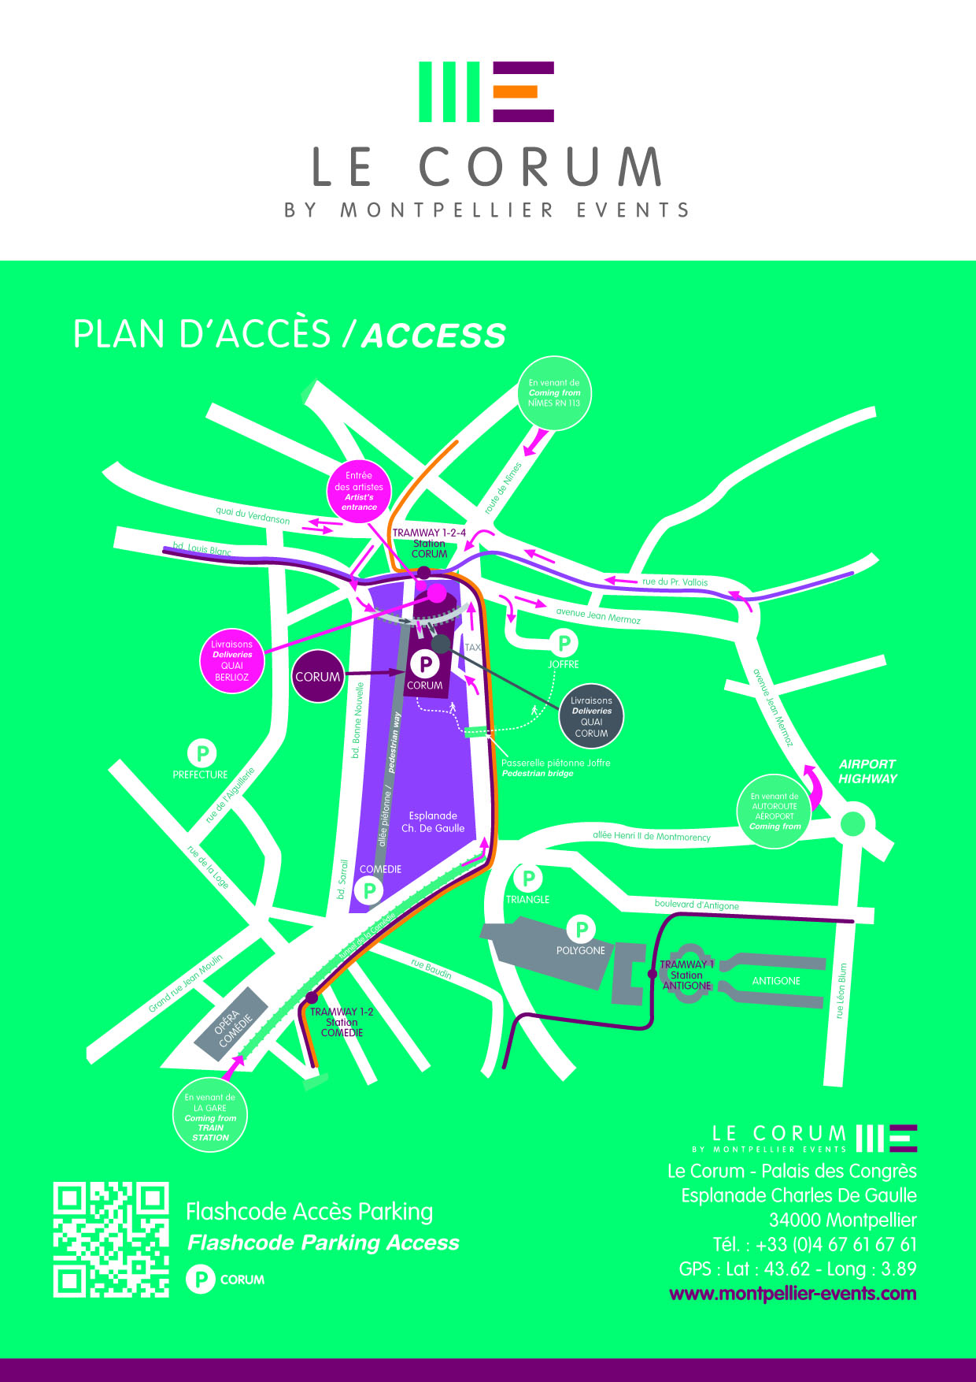

Exhibition services

○ Catering and Bar

The Brasserie of Le Corum (100 places) level 0 to Le Corum, is opened during the congress
(closed on sunday).
To welcome visitor to your stand with cocktails, buffets…
You can get in touch with :



HUSSER BRASSERIE DU CORUM
Esplanade Charles de Gaulle
34 000 Montpellier - FRANCE
Tel : 33 4 67 59 83 49
fyve34@gmail.com
www.brasserieducorum.fr

○ Shipping Company

SOCIETE CLAMAGERAN
Contact : Lucien LAWSON
Tel : 33 1 57 25 18 09
gsm: 33 6 20 83 78 00
l.lawson@clamageran.fr

General Instructions

○ Floors, walls, pillars of Le Corum

It is strictly forbidden to drill holes, screw, stick to the floor, post, partitions inside Le Corum. It is also forbidden to carry out any kind of work affecting smoke, water, compressed air pipes, electric, telephone
wires in the building.

Any repair work made necessary by the failure to observe the above rules will be at the exhibitor's expense.

The decoration items (partitions, furniture, poster, signboard…) should not exceed the bounds of the stand delimited by the carpet on the floor, or a floor marking if the stands are provided without carpet..

○ Stand fitting provided by Le Corum

The height of partitions walls provided by Le Corum is 2.40 m.

Le Corum has put clean partition walls at your disposal. In order to protect the quality of this material, the exhibitor is not allowed to use any other fixing material than picture rails and special double faced tape. The technical team of Le Corum will hire this kind of fixing material upon request during the setting up.

○ Empty spaces fitted out by stand fitters

Don’t forget to submit the whole exhibitor technical file to a professional decorator or stand fitter.

Stand fitters who fit out empty spaces, must send a plan of stand layout to Le Corum, 30 days before setting up begins. Any stand layout that should exceed the height of 2.40 m needs written authorization from the Organizing Committee and Le Corum.

○ Insurance
A copy of an insurance certificate must be forwarded to Le Corum at least 15 days before setting up begins.
Be careful

Exhibitors must be individually insured for their professional civil liability and take out an all-risks insurance policy including setting up, stocking, dismantling and forwarding with their own company.

○ Advertising

It is forbidden to fix billboards or distribute commercial fliers anywhere else than on the stands. In case of offence, the documents will be systematically thrown.

Safety – Surveillance and Caretaking

○ Safety – Surveillance

Fire safety and surveillance of the Corum are undertaken, all the year round, by a company, under contract to the Palais des Congrès.

○ Safekeeping
It is up to each exhibitor to keep an eye on his/her stand, not to leave valuable objects on the stands outside opening hours and be very careful when setting up and dismantling the stands.
Be careful

The organizer is responsible for the caretaking of the premises of the congress and the exhibition, but this is an obligation of means and not of result.

If you want to hire a security guard, you can get in touch with the manager of the event at the Congress Management Department by calling the number 33 4 67 61 67 61.

Safety Measures

The exhibitor must return to Le Corum, the certificate enclosed in the file duly completed and signed, in so doing agreement is given to respect all safety measures applicable to the congress and set down in the rule hereunder.

=

1. REGULATIONS

All obligations set down in this document are specified by the Government Decree of November 18, 1987.

2. OBLIGATIONS OF THE EXHIBITORS AND STAND HOLDERS

2.1. Administration inspection :

The stand fitting must be finished by the time the safety committee passes for inspection.

During the inspection either the exhibitor or an authorized representative must be present and give any information required concerning the setting up and the material.

The organizer declines all responsibility in the event of a Committee decision to close down a stand due to no-respect of rules and regulations.

2.2. Legal clauses :

The organizer must be notified one month in advance of the public opening of all machines in operation on the stands. Combustion engines, smoke generators, propane gas, dangerous gas, radioactive sources, X rays and lasers displayed on the stands must have written authorization from a relevant authority one month before the public opening. The organizer will forward this request for authorization to the necessary administration.

The security manager selected by the organizer will inform stand holders of the specific arrangements concerning the above information and all relevant stand holders will be notified of the administration’s decisions.

3. STAND FITTING

3.1. Depending on their inflammable properties, the stand materials are divided into 5 categories :

- MO (incombustible) ;
- M1 (no inflammable) ;
- M2 (inflammable with difficulty) ;
- M3 (relatively inflammable) ;
- M4 (easily inflammable).

3.2. Proof of classification must be provided :

- either by test results undertaken by a recognized laboratory,
- or certified by officially recognized standards (for Great Britain, the BSI)

For fireproof material, proof must be given as to its reaction :
- either by identification if the fireproofing takes place
in a factory or workshop,
- or by a stamp or seal if the fireproofing takes place “ on site ”.

Traditional materials with the following classification do not need proof of classification :

- Classification MO : glass, brick, plaster, slate, iron, steel, aluminium, ceramic products ;
- Classification M3 : soft wood at least 14mm thick, soft wood and wooden panels (plywood composites, hardboard composites)
at least 18mm thick ;
- Classification M4 : hard wood, less than 14mm thick, soft wood and wooden panels of less than 18mm thick.
3.3. The materials used must have the following classification :

- making and fitting the stands mainly with partitioning
and framework : M3 ;
- plastic flower decoration in large quantities : M2 ;
- coverings for podiums, rostrums or tiers :
- M3, if the height is over 0.30 m and the surface area over
20 sq m
- M4 in other cases.
- cover and eventual outer cover and tie lines for marquees or tents M2 ;
- horizontal awnings: M1 (M2 classification, if the building
is protected by an automatic sprinkler system).

3.4. The stands may only have one raised level.

3.5. Stands with ceilings, false ceilings or awning and stands with a raised level must follow these conditions :

- surface area less than 300 sq m
- total surface area of ceilings, false ceilings equal to 10 %
of the floor surface area.

4. ELECTRICAL INSTALLATIONS

4.1. The electrical installations on the stands come from a power point accessible at all times to stand-holders.

These installations are made in compliance with the NFC15-100 standards; exhibitors are entirely responsible for their use.

4.2. The main rules are as follows :

- flexible cables must be used for a voltage of at least 500 V,
- the plug socket power supply must be protected with a device for 16 Amp or less,
- all cables must have a short circuit conductor linked to the earth in the stand box,
- individual earth plugs are forbidden,
- “ O ” classified appliances must be protected by nominal differential current fuses with a maximum of 30 Amp.

5. ELECTRICAL INSTALLATIONS

5.1. There must be easy access to the main power cut-off switch of each stand at all times.

5.2. If the stand is left unattended the main power cut-off switch
for that stand must be in the off position.

5.3. The stand installation must be completely dismantled at the end of the exhibition.

6. USE OF BOTTLED PROPANE OR BUTANE

6.1. Only bottles containing 13 kg of gas or less are allowed.

6.2. The bottles must always be fitted with pressure reduction valves conform to standard.
These extinguishers must be used by a specialist.

6.3. All connected bottles must be out of public reach and protected against shocks.
Each stand is limited to 6 bottles. Connected bottles must be at least 5 meters from each other or separated by a solid fireproof screen with one bottle installed every 10sqm.

Safety Measures
(to be continued)

6.4. Flexible connecting pipes :
- must comply with the corresponding diameter standard,
- must be less than 2 meters in length,
- must not be used after the expiry date on the pipe.

6.5. Disconnected bottles must not be kept inside the building.

7. INDEPENDANT HEATERS

All types of independent heaters, electric, gas or solid fuel is strictly forbidden.

8. FIRE PRECAUTIONS

  - Stand installation must in no way block fire fighters access to extinguishers or smoke control equipment.

8.2. Stand with ceilings, false ceiling or awnings and stands with
a raised level must be equipped with portable fire extinguishers when the surface area is over 50 sq m.

9. INFLAMMABLE LIQUIDS

Inflammable liquids are limited on each stand as follows :

- 2nd category inflammable liquid (fuel oil, diesel, and alcohol over 40°C.) : 10 litres for 10 sq.m with a maximum of 80 litres.
- 1st category inflammable liquids (benzene, methylbenzene, hexane, butanol, sylene, turpentine,...) : 5 litres.

Highly inflammable liquids (ethylene oxide, carbon bisulphide, and ether) are strictly PROHIBITED.

10. PROHIBITED PRODUCTS

The following products are forbidden on the stands :
- samples of products containing an inflammable gas,
- balloons inflated with poisonous, or inflammable gas,
- celluloid articles,
- explosives and fireworks,
- ethyl oxide, carbon sulphide, sulphuric ether and acetone,
acetylene, oxygen and hydrogen (except with official
authorization).

○ Rules application :

On signing the admission form, the exhibitor agrees to comply with all clauses present in this document as well as the general congress rules.

If these rules are infringed in any way, this will lead to the immediate exclusion of any infringing exhibitor or company at the discretion of the Organizing Committee.

This also applies to non-insured exhibitors, non-conformity of equipment, failure to comply with safety regulations, the payment schedule, non-occupied stands, non-payment of additional services, etc… The Organizing Committee has the right to remove any exhibited items, furniture or decoration belonging to the exhibiting company.
If any objections are raised, the Commercial Court of Montpellier is the only competent body in this matter, the French version of this written document is considered as the authentic text.

Stand equipment

○ Technical description of stand fittings provided by Le Corum

▪ Partitions made of beechwood 2.40 m x 1m (useful surface : 0.945m x 2.389m)

▪ Aluminium posts in black spray

▪ Front signboard made of beechwood size 3 m x 0,25 m

▪ 1 Reversible flag type signboard size 30 cm x 42 cm (useful surface : 29,7 cm x 42 cm) with the
stand name (See form enclosed, to be returned to Le Corum)

▪ 2 Kw capacity power supply

▪ 1 set of three adjustable spotlights (3 x 100 Watts)

▪ Carpet on the floor : GREEN PISTACHIO (N°9661)

▪ Furniture : 1 white rectangular table and 3 black chairs

6 sq m layout (3m x 2m)

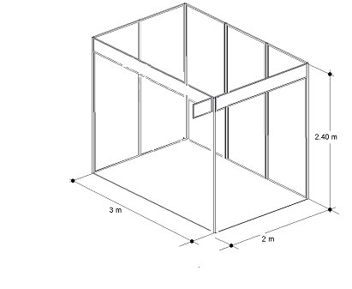 | 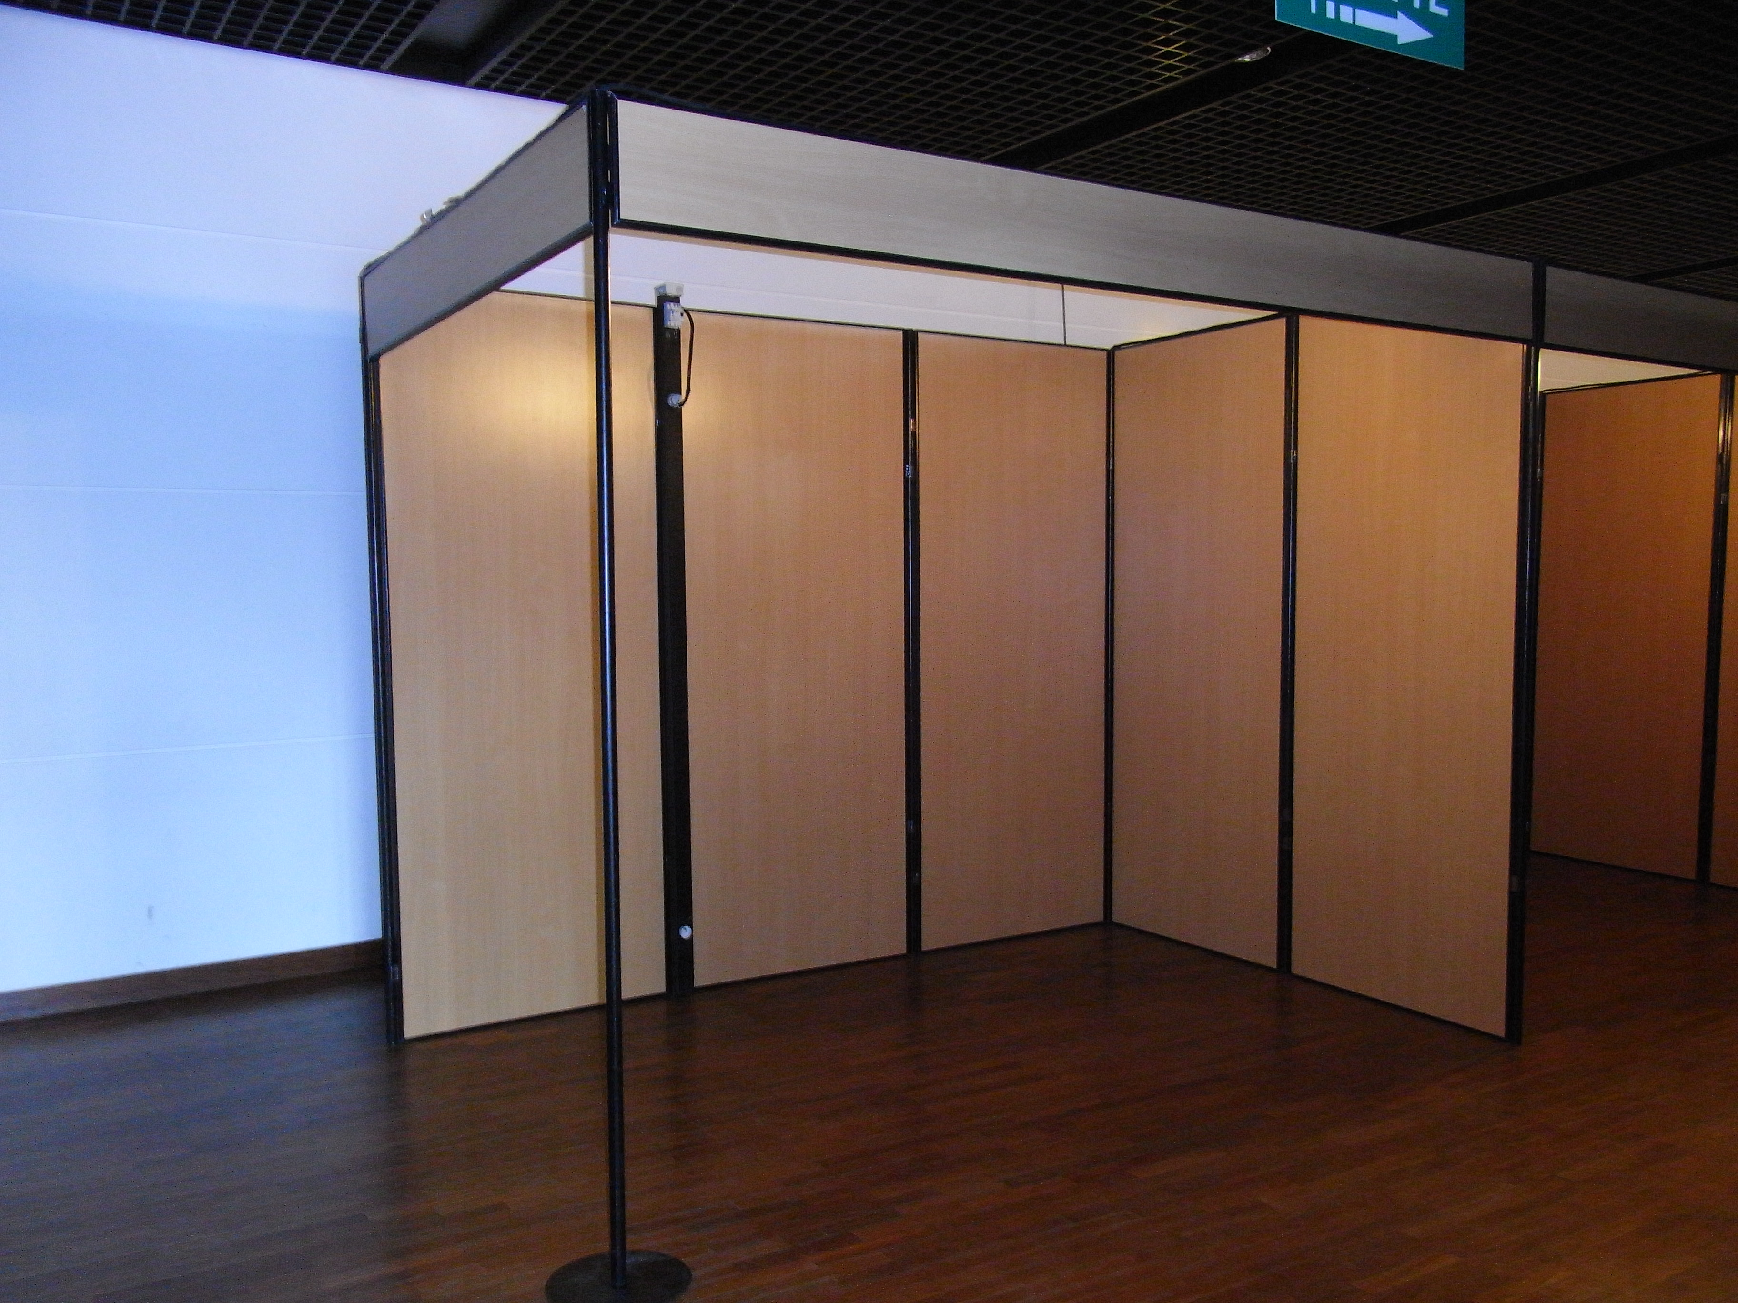

Be careful : For security reasons, general electric power is interrupted from 7:00 pm to 5:00 am. You can order 24/24 power on your booth, by calling the CORUM production department which will send you an additional invoice. No permission will be given on site.

Power supply

○ If you have an equipped stand

● If so, the electrical power supply varies according to the stand size as on the following table :

 | 6 sq m | 9 sq m | 12 sq m | 15 sq m | 18 sq m | 21 sq m | 27 sq m
Electrical power | 2 kW | 2 kW | 2 kW | 2 kW | 2 kW | 2 kW | 3 kW
Set 3 spotlights | 1 | 1 | 1 | 1 | 2 | 2 | 3

● For safety reasons, each electrical connection provided by Le Corum will only supply one stand.

● On the lay-out last page, please show us the required location to fit up the electrical plug.

Reminder : 1kW = 1000 W
3 spotlights = 300 Watt
1 computer = 500 Watt
1 coffee machine = 500 Watt
1 fridge = 500 Watt
News

Order form page 20
Deadline for order
JULY 16, 2018
For ordering
○ If you have a non-equipped stand

● Please order us your power supply.

Be careful : For security reasons, general electric power is interrupted from 7:00 pm to 5:00 am. You can order 24/24 power on your booth, by calling the CORUM production department which will send you an additional invoice. No permission will be given on site.

Telephone - Internet

Phone :
Order form page 20
Deadline for order
JULY 16, 2018
For ordering

- Further invoicing if units are beyond : 0,18 € (V.A.T. included).
- The phone receiver is to be taken out at the reception desk during setting up.

Order form page 20
Deadline for order
JULY 16, 2018
For ordering
Connection to Internet DSL/WIRED :

- Connection DSL Internet via Ethernet Network 2 Mb/s – UNGUARANTEED IP FLOW
- Rental computer is available.
- Set price including connection and units.

Various services

Order form page 20
Deadline for order
JULY 16, 2018
For ordering
2 sq m storeroom

- The storeroom has 2 partitions and a door with a lock and a key. If you need a larger surface you can order extra partitions.
- Locate it on the plan at the last page.

Order form page 20
Deadline for order
JULY 16, 2018
For ordering
Stand cleaning

- The organizer is in charge of the cleaning of the exhibition common spaces only.
- It’s up to each of the exhibitors to order the cleaning of their stands after the setting up and daily.
- This operation includes : the removal of the polyane, vacuum cleaning and rubbish collection.

Order form page 20
Deadline for order
JULY 16, 2018
For ordering
Computer, printer

- Rental computers and printers are available at the Corum.
- Multimedia PC (17’ monitor) configured for an Internet connection.
- Laser printer black and white.

Rules and safety measures certificate

Company : ……………………………………………………………………………………………………………..

Address :………………………………………………………………………………………………………………..

….

Postal code : ……………………Town : …………………………… Country : ………………….……………

Phone : ……………………………….Fax : ………………………………E.mail : ………………………………

Contact : ………………..………………………………………………………………………….….……….………

BEFORE
JULY 16, 2018
to Le CORUM
Service Régie
Congrès Expositions
BP 2200
34027MONTPELLIER
CEDEX 1 - FRANCE
To be returned
The exhibitor has to send back this certificate duly completed and signed to Le Corum, in which the exhibitor declares to respect the exhibition specifications and safety measures and all safety rules and regulation. A copy of the exhibition specification document has to be passed on to all sub-contractors appointed by the exhibiting company.

I, undersigned, Mr/Mrs. …………………., from …………….……… and acting as ……………………………………………., hereby certify having received from the Organizing Committee, a copy of the exhibition specification document which applies the safety measures from the order of the 18th November 1987 and includes all rules and regulations to be respected by exhibitors and stand-holders.
I hereby declare to respect the exhibition document and have my company and any subcontractor I appoint respect the document.

Date and signature :
Company stamp :

Signboard Form

Company : …………………………………………………………………………………………………………….

Address :………………………………………………………………………………………………………………..

….

Postal code : ……………………Town : …………………………… Country : ………………….…………

Phone : ……………………………….Fax : ………………………………E.mail : ……………………………

Contact : ………………..………………………………………………………………………….….………...

This form is only for equipped stands – STAND N° :

All signboards are standardized, with a reversible flag type signboard 29,7 cm x 42 cm.
If no completed order is returned, the organizer will decide the text of the signboard instead of the exhibitor.
To be returned
BEFORE
JULY 16, 2018
to Le CORUM
Le CORUM
Service Régie
Congrès Expositions
BP 2200
34027MONTPELLIER
CEDEX 1 - FRANCE

Maximum of 16 capital
letters – no logo
This service
is obligatory and free
Be careful

Date and signature :
Company stamp :

Order form
Electricity – Telephone/Internet – Various services – Cleaning
Company : ………………………………………………………………………………………………………

Address :………………………………………………………………………………………………………………

….

Postal code : ……………………Town : …………………………… Country : ………………….……………

Phone : ……………………………….Fax : ………………………………E.mail : ……………………………

Contact : ………………..………………………………………………………………………….….……….………

Address of invoicing (if different) :………………………………………………………………………………...

Technical services
Electricity
Nomination | Unit Price € | Quantity | Total €
2 kW single 220 V (plug 16A) | 186.50 €
3 kW single 220 V (plug 16A) | 197.50 €
6 kW single (= 2 x 3 kW single) | 239.50 €
6 kW three phase electricity  supply 380 V (10A terminal) | 257.00 €
Any other electrical supply = On request
Contact : Management department
Telephone/Internet
Phone and analog  connection (including units) | 99.00 €
Connection to Internet :  WIFI  or WIRED  | 112.00 €
Various services
1 sq m storeroom | 130.50 €
2 sq m storeroom | 149.50 €
Cleaning
Nomination | Price sq m € | Sq m | Total €
Individual stand cleaning  (sq m set price) | 4.80 €
Thank you to write below your VAT Intracom number : |  | Total €  V.A.T 20,00 % included
For ordering

BEFORE
JULY 16, 2018
to Le CORUM
attached of the full
payment to
LE CORUM
BP 2200
34027MONTPELLIER
CEDEX 1 - FRANCE

The order will not be
confirmed until the full
payment is received.

Be careful

Date and Signature
Company stamp
PAYMENT
○ By check payable to SAEML MONTPELLIER EVENTS / LE CORUM sent to :
MONTPELLIER EVENTS / LE CORUM - BP 2200
34027 MONTPELLIER CEDEX 1 - FRANCE
○ By bank transfer payable to SAEML MONTPELLIER EVENTS / LE CORUM
Location : CE LR – DMS CIL CA MONTPELLIER
IBAN : FR76 1348 50008 0008 9137 5669 568 BIC : CEPAFRPP348

Stand layout
Technical sevices

Please show us the required location to fit up the electrical plug, Internet and/or the storeroom.

E = Electrical plug T = Telephone I = Internet S = Storeroom

Map attached at the
order form BEFORE
JULY 16, 2018
Be careful
Date and Signature
Company stamp
Company :
Phone :
Scale : 10 squares = 1 metre

